Kalamazoo Area Bike Week Coming May 11-18, 2024
Contact: Isaac Green, Chair
bikeweek@bikefriendlykalamazoo.org (email); (269) 686-6167 (cell)

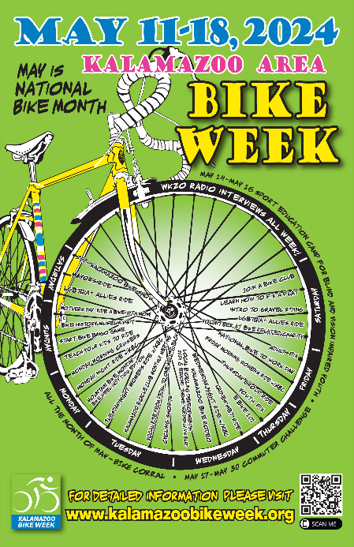
Kalamazoo Area Bike Week returns in 2024, starting Saturday May 11 with daily events running through Saturday, May 18. Bike Week is one of the most event filled week-long celebrations of bicycling in the United States. It features more than 30 featured activities, including:

Bike Week 2024 spotlights:
- Locally available bicycle clubs, riding groups and shops
- Group riding on the roads
- Organized trail riding opportunities
- Lessons on how to get bikes ready to ride and fix a flat
- Teaching kids to ride safely
- Local bicycling developments
- Informational webinars
- Dirt & gravel road riding
- Public safety messaging
- Local bike-related nonprofits.

Bike Week highlights the many fun bicycling events that take place throughout the year and helps underscore need to drive and bike safely. Bike Week Events and Announcements are being added almost daily at its official website at www.kalamazoobikeweek.org and on Facebook at @kalamazoobikeweek. Bike Week offers plenty of reasons to get out there and enjoy the great outdoors!

